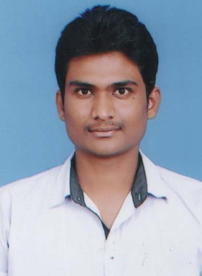
RESUME
E.Premraj,
S/0. E.Devaiah,
H.No:17-1-15/2,
Sanjaygandi nagar,
Godavarikani, epremraj92@gmail.com
Karimnagar Dist. Mobile No:8520877938
_____________________________________________________________________

Career Objective:

To prove myself dedicated in a progressive organization that gives my knowledge and skills and be a member of a team member of a team that dynamically works towards success and growth of the organization.

Education Profile:

- Completed Degree B.com (computers) from AUROBINDO DEGREE COLLEGE affiliated to Sathavahana University.

- INTERMEDIATE (C.E.C) from Sachdeva Jr. College, NTPC.

- SSC from SRR high School, GDK .

Computer Skills:

- Ms-Office.

- FRESHER

Hobbies:

- Reading Books& playing cricket.
- Watching TV

Strengths:

- Strict commitment to the tasks.
- Good analytical and decision making ability.
- I can grasp the work easily.
- Ability to work under pressure and highly flexible .
WORK EXPERIENCE : Working as an phone banking officer with ICICI BANK for the period of 1 year
PERSONAL SKILLS:

posses a big heart to face challenges
Can take initiative and work independently or as a part of groups

PERSONAL PROFILE:

Name : E.Premraj

Father’s Name : E.Devaiah

Date of Birth : 06-10-1992

Sex : Male

Nationality : Indian

Religion : Hindu

Material Status : Unmarried

Languages Known : Telugu , Hindi & English

Permanent Address : E.Premraj,
. S/0 E.Devaiah,
Flat No: 17-1-15/2,
Ramagundam, Karimnagar Dist.

Declaration:

I do hereby declare that the particulars of information and facts furnished above are true and correct to the best of my knowledge and belief.

Date:
Place: (E.Premraj)

